Michigan Clean school bus program

current situation
The VW Settlement creates a unique opportunity for the state of Michigan to modernize its school bus fleet to lower emission vehicles and air quality and support school districts across the state. Under the parameters of the settlement Michigan is eligible to receive $60, 329,906.41. The funds are to be used to offset the damage created by VW vehicles that operated in the state in violation the Clean Air Act. One of the central components of eligible funding is the replacement of older diesel school buses with alternatively fueled school buses, including CNG and propane. In order to receive this funding, the state of Michigan must file a plan with US EPA and that plan needs to include the state’s general ideas for use of the funding. This proposal outlines the parameters of a program that will replace up to 5% of the school buses in Michigan, with alternative fuel versions and leveraging limited school district funds.
The State of Michigan operates approximately 16,000 school buses to transport almost 700,000 students to and from school each day. The average service life of each school bus is 15 years, meaning some Michigan school districts have buses operating in the field dating back to 2000, well before the most recent emissions regulations on diesel engines.
Most school buses are currently powered by diesel fuel. Pre-emission diesel buses contain ozone-forming nitrogen oxides (NOx) and toxic pollutants. Students who ride these older generation diesel school buses are at risk of accelerating asthma, respiratory illnesses and heart disease. Pre-emission diesel buses have also been linked to ground-level ozone formation and climate change. One way to reduce the volume of diesel emissions released into Michigan’s atmosphere is to replace those diesel buses with clean-burning, alternatively fueled models.

why alternative fuels
Alternatively fueled school buses, specifically, propane, are gaining popularity in Michigan. Currently, there are 28 school districts running propane school buses in the state, out of 900 total school districts. While adoption is increasing, only 3 percent of the school districts in Michigan operate propane school buses to date.
Propane autogas is an excellent fuel choice for school buses because it assist in reducing harmful emissions from the environment. Compared to diesel, propane school buses emit 60 percent fewer NOx emissions, 80 percent fewer smog-producing hydrocarbons, and provide a 100 percent reduction in particulate matter (PM). School bus manufacturer Blue Bird currently offers a propane school bus that is four times cleaner than the standard when comparing NOx levels. This means children who ride in propane school buses breathe cleaner air every day.
Propane school buses provide financial and maintenance benefits to districts operating them. A district does not need to purchase and install pricey diesel after-treatment, such as maintenance parts and fluids. Those components are completely eliminated with buses powered by propane because of the clean-burning properties of the fuel.
Propane autogas also costs less per gallon. For more than 30 years, the cost of propane autogas has been, on average, 30 to 40 percent less than the cost of gasoline. The cost differential between propane autogas and diesel is 40 to 50 percent.

program outline
Utilizing funds from the VW settlement, the proposal is for the establishment of the Michigan Clean School Bus program that would:
- Replace 5 percent of the diesel buses in the state with clean-burning propane autogas buses by investing approximately $32 million from Michigan’s share of the VW settlement.
- Provide a 50 percent rebate for the total cost of a new propane autogas school bus.
Every school bus removes approximately 36 cars off the road, which results in less traffic congestion and reduced carbon footprint. The Michigan Clean School Bus program represents an opportunity to accelerate replacement of 5 percent of Michigan’s school buses with alternative fuel-powered replacements. By targeting pre-2007 model year school buses, the program would reduce emissions by 630 tons of NOx emissions per year and 18 tons of PM emissions per year from the atmosphere.
Not only would this program result in a cleaner environment for our children and communities, it would create jobs and infrastructure to support the mass deployment of new buses. Further, additional fleet operators in Michigan would benefit from the increase in propane infrastructure throughout the state, allowing them to replace diesel engines with propane, thus compounding the air quality improvements through this investment.

Energy and Emissions Impact
Replacing 800 diesel school buses with propane alternatives would reduce Michigan’s petroleum usage by 2 million diesel gallons.
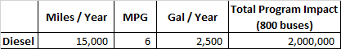
Potentially, the Michigan Clean School Bus program could achieve significant NOx and PM reductions. By removing 800 pre-2006 model-year diesel school buses from the road, 571,680 kg or 630 tons per year of NOx would not be emitted. Additionally, 16,128 kg or 18 tons of PM per year would be reduced.
See Appendix A for the model used to determine the emissions values. We targeted approximately 800 school buses, or 5 percent of the Michigan school bus population. Seventy-five percent (75%) of the targeted older diesel bus population was assumed to be between 1998 and 2003 model years, while the other twenty-five percent (25%) to be between 2004 and 2006 model years. The result was compared to a 2017 model-year propane school bus.

Administration
Michigan’s dealer for Blue Bird school buses is Holland Bus Company, located in Holland. They would work with school districts to determine candidates for funding. As interested school districts decide to move forward, Holland would submit a ‘request for purchase’ form the administering body of the funds to explain how many buses that district would replace. The administrator would have the authority to approve or deny the request.
Once approved, the school district would submit a purchase order for the number of school buses they’d like to purchase, minus the funding amount, to Holland Bus Company.
After the new propane buses are delivered, Holland Bus would submit a proof of delivery form for the number of buses purchased to the administrator. The form includes the VIN number of the bus being replaced, the VIN of the new bus being put into service, and the scrappage information for the old bus.
Once all paperwork has been approved, the administrator will provide the rebate to Holland Bus Company.

reporting
Reporting will be required annually for the school districts that receive funding for new buses. There will be a template created that requests the following information:
- VIN number of the new propane bus
- Total miles currently on the bus
- Total miles driven that year
- Maintenance costs by bus for the year
- Fuel costs for each bus for the year
With the mileage information, the administrator can demonstrate the NOx reduction achieved in that year with the new propane buses in operation. To promote the story, the administrator can use the maintenance and fuel cost savings to explain the financial benefits of the propane school buses.
Scrappage information on the old diesel bus will also be linked to the VIN number of the new bus so that can be referenced in the future if needed.

executive summary
The Michigan Clean School Bus program will be an excellent way to propel the State of Michigan into a leader in the movement to replace diesel school buses that are polluting the environment. This program provides an environmentally responsible effort that will also help create local jobs in the alternative fuels and infrastructure industries.
Because the program also helps reduce maintenance and fuel costs for school districts, those savings can be put back where they’re most important — our classrooms. Schools can reallocate those funds toward school supplies, books and other materials that will help our children get more out of their education.

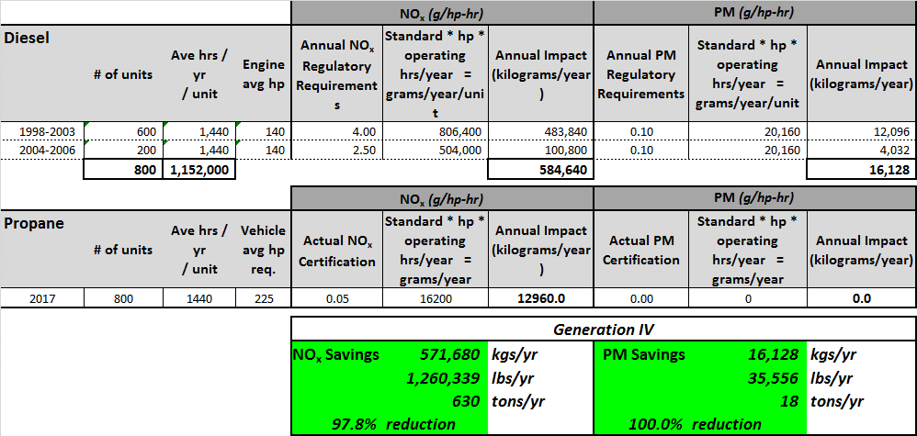
appendix A: Emissions calculator

appendix b: School bus diesel exhaust study
See attached study performed by Environment & Human Health, Inc.

appendix c: Zeeland Public Schools Testimonial
See attached testimonial by the Propane Education & Research Council.

Appendix B
Appendix C

